**IMPROVE PRODUCTIVITY THROUGH**

**INVENTORY MANAGEMENT SYSTEM**



DB&QP MINI PROJECT

TE COMP

SEM V

**Sem:V**

**Academic Year:** 2022-23 **Date:** 19/12/2022

**DBMS&QP LAB MINI PROJECT SYNOPSIS**

**Title**: Inventory Management System

**Abstract:**

An inventory management system is the combination of technology (hardware and software) and processes and procedures that oversee the monitoring and maintenance of stocked products, whether those products are company assets, raw materials and supplies, or finished products ready to be sent to vendors or end consumers.

**Objectives:**

1. Planned approach towards working: - The working in the organisation will be well planned and organised. The data will be stored properly in data stores, which will help in retrieval of information as well as its storage.

2. No Redundancy: - In the proposed system utmost care would be that no information is repeated anywhere, in storage or otherwise. This would assure economic use of storage space and consistency in the data stored.

3. Immediate retrieval of information: - The main objective of the proposed system is to provide for a quick and efficient retrieval of information.

4. Easy to Operate: - The system should be easy to operate and should be such that it can be developed within a short period of time and fit in the limited budget of the user.

**Identifying End Users**

· Admin

**System Requirements**

**Tools to be used**

**Front End tools:**- HTML,CSS, JavaScript

**Back End Tools:-** Php,MySql

**IDE:** Visual Studio Code

**Server:** XAMPP

**Website UI**

Homepage.php

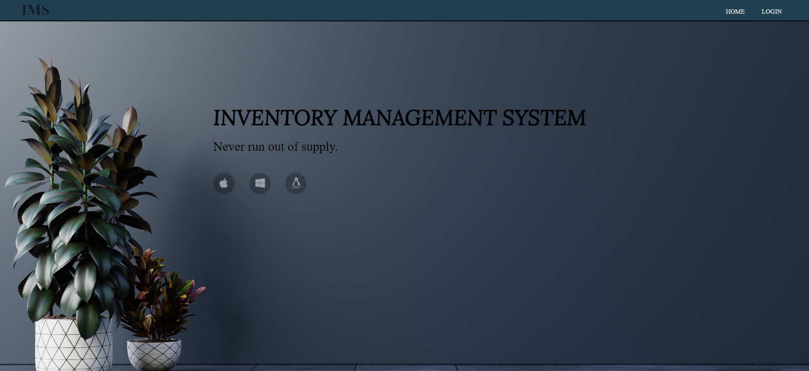



Login.php



Dashboard.php

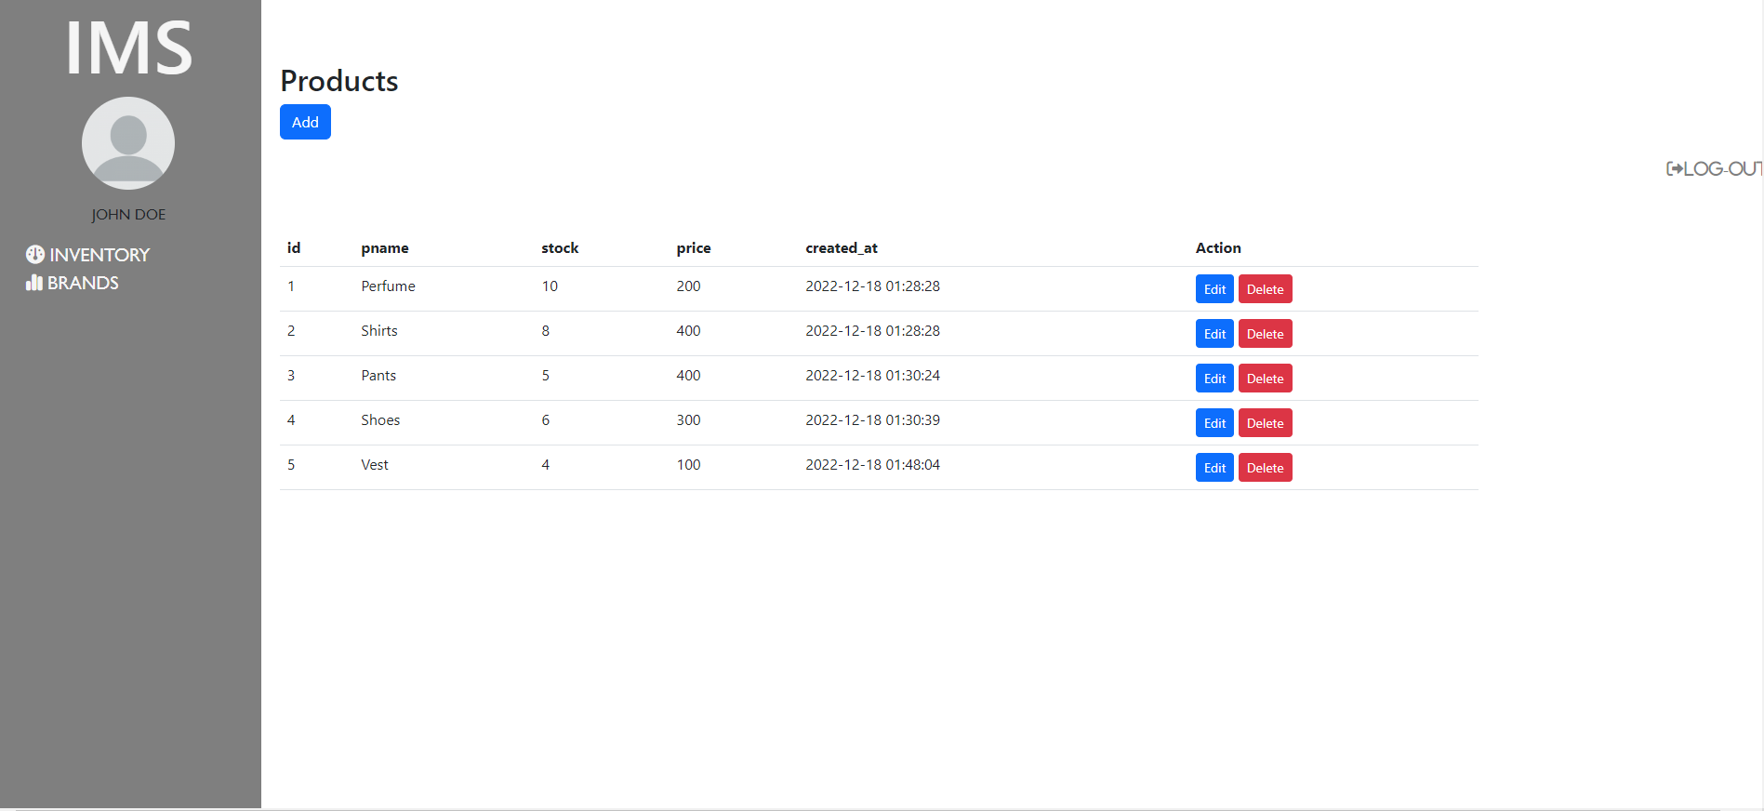

Brands.php

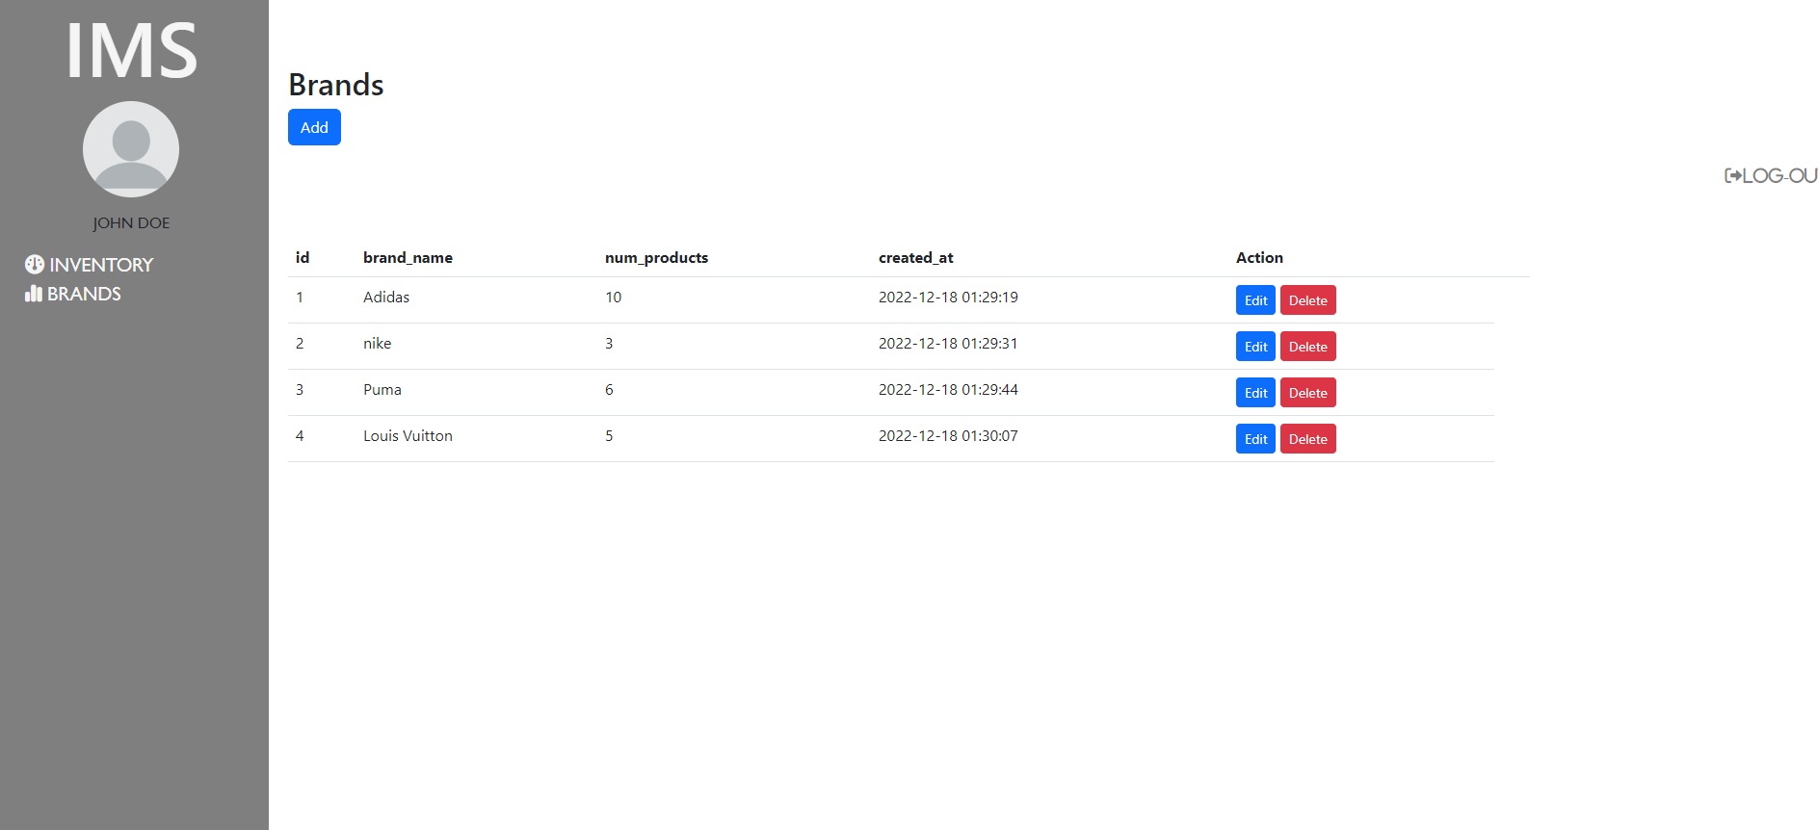

Create.php



Add.php

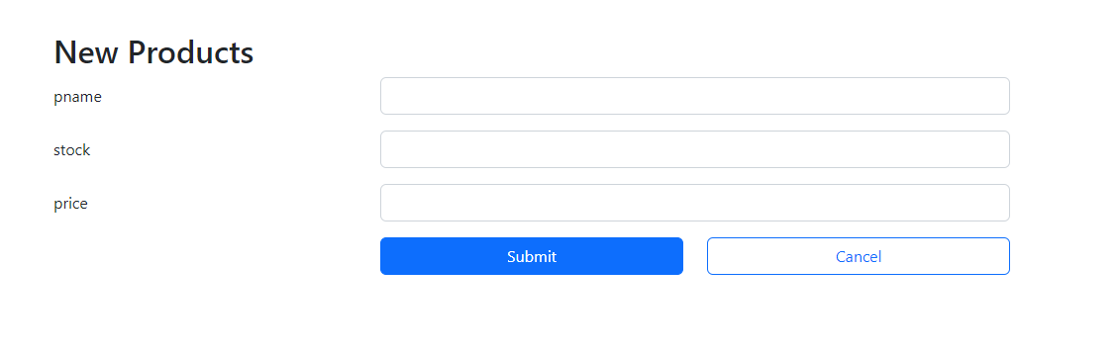

Update.php

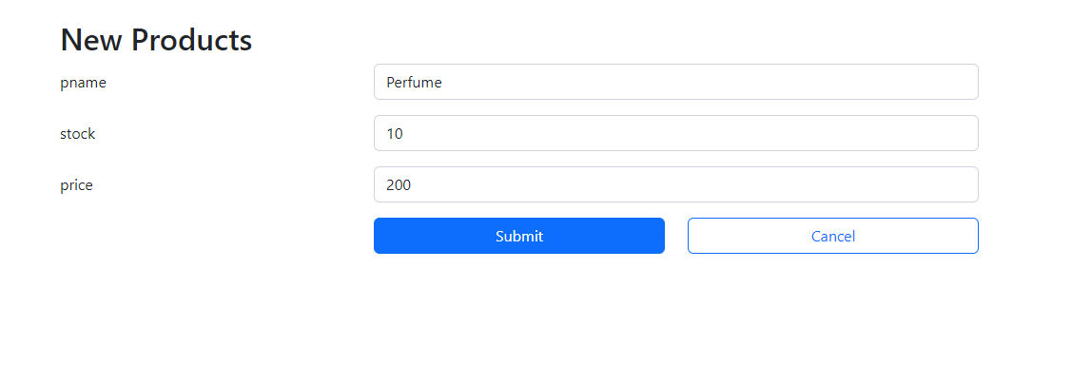

About.php



